**REST - Country Web Service**

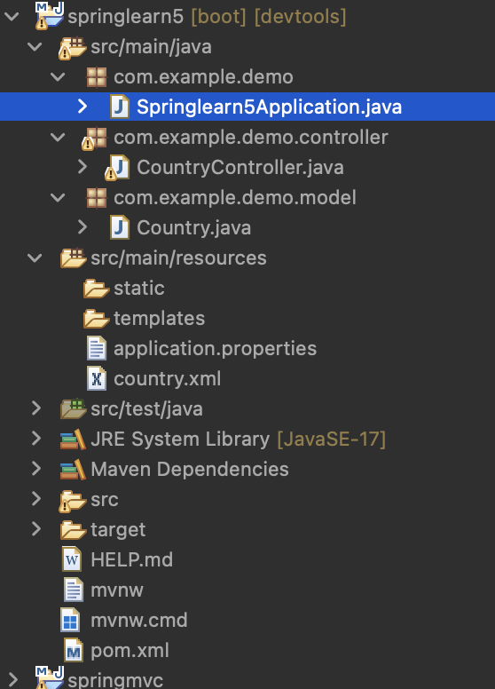

package com.example.demo;

import org.springframework.boot.SpringApplication;

import org.springframework.boot.autoconfigure.SpringBootApplication;

@SpringBootApplication

public class Springlearn5Application {

public static void main(String[] args) {

SpringApplication.run(Springlearn5Application.class, args);

}

}

package com.example.demo.controller;

import org.springframework.context.ApplicationContext;

import org.springframework.context.support.ClassPathXmlApplicationContext;

import org.springframework.web.bind.annotation.RequestMapping;

import org.springframework.web.bind.annotation.RestController;

import com.example.demo.model.Country;

*@RestController*

public class CountryController {

*@RequestMapping*("/country")

public Country getCountryIndia()

{

ApplicationContext context=new ClassPathXmlApplicationContext("country.xml");

Country country=(Country)context.getBean("in");

return country;

}

}

package com.example.demo.model;

public class Country {

private String name;

private String code;

public Country() {

}

public Country(String name, String code) {

super();

this.name = name;

this.code = code;

}

public String getName() {

return name;

}

public void setName(String name) {

this.name = name;

}

public String getCode() {

return code;

}

public void setCode(String code) {

this.code = code;

}

}

<?**xml** version=*"1.0"* encoding=*"UTF-8"*?>

<**beans** xmlns=*"http://www.springframework.org/schema/beans"*

xmlns:xsi=*"http://www.w3.org/2001/XMLSchema-instance"*

xsi:schemaLocation=*"*

*http://www.springframework.org/schema/beans*

*http://www.springframework.org/schema/beans/spring-beans.xsd"*>

<**bean** id=*"in"* class=*"com.example.demo.model.Country"*>

<**property** name=*"code"* value=*"IN"*/>

<**property** name=*"name"* value=*"India"*/>

</**bean**>

</**beans**>

<?xml version="1.0" encoding="UTF-8"?>

<project xmlns="http://maven.apache.org/POM/4.0.0" xmlns:xsi="http://www.w3.org/2001/XMLSchema-instance"

xsi:schemaLocation="http://maven.apache.org/POM/4.0.0 https://maven.apache.org/xsd/maven-4.0.0.xsd">

<modelVersion>4.0.0</modelVersion>

<parent>

<groupId>org.springframework.boot</groupId>

<artifactId>spring-boot-starter-parent</artifactId>

<version>3.5.3</version>

<relativePath/> <!-- lookup parent from repository -->

</parent>

<groupId>com.cognizant</groupId>

<artifactId>springlearn5</artifactId>

<version>0.0.1-SNAPSHOT</version>

<name>springlearn5</name>

<description>Demo project for Spring Data JPA and Hibernate</description>

<url/>

<licenses>

<license/>

</licenses>

<developers>

<developer/>

</developers>

<scm>

<connection/>

<developerConnection/>

<tag/>

<url/>

</scm>

<properties>

<java.version>17</java.version>

</properties>

<dependencies>

<dependency>

<groupId>org.springframework.boot</groupId>

<artifactId>spring-boot-starter-web</artifactId>

</dependency>

<dependency>

<groupId>org.springframework.boot</groupId>

<artifactId>spring-boot-devtools</artifactId>

<scope>runtime</scope>

<optional>true</optional>

</dependency>

<dependency>

<groupId>org.springframework.boot</groupId>

<artifactId>spring-boot-starter-test</artifactId>

<scope>test</scope>

</dependency>

</dependencies>

<build>

<plugins>

<plugin>

<groupId>org.springframework.boot</groupId>

<artifactId>spring-boot-maven-plugin</artifactId>

</plugin>

</plugins>

</build>

</project>

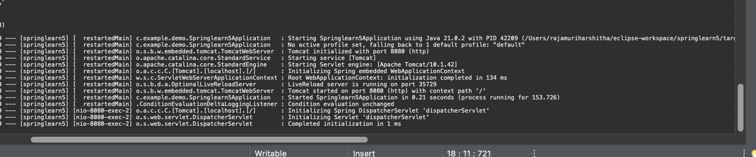

Output:

